USING FIJIWINGS TO UNDERSTAND THE GENETIC CONTROL OF CELL GROWTH AND PROLIFERATION

Module 1: Introduction to Fijiwings

Objective: to understand how Fijiwings is used to measure tissue and cell size

Introduction

Body size, a characteristic feature that distinguishes species, populations and sexes, is the product of cell growth, cell division frequency and time. During early development, tissue growth rate is influenced by both genetic and environmental factors while the end of growth is often triggered by hormonal signals (Edgar, 2006; Mirth and Riddiford, 2007). To regulate growth, cells have intrinsic mechanisms to measure local energy levels (such as ATP concentration) but systemic signals such as insulin coordinates the rate of tissue growth in disparate organs (Caldwell et al., 2005; Colombani et al., 2005; Mirth et al., 2005).

The fly wing forms during the larval stages from an epithelial sheet that proliferates exponentially, roughly doubling in mass over a 10–12 hour period (Held, 2002). The wing disk epithelium everts at metamorphosis to form the wing blade, which is (1) marked by longitudinal and cross veins that provide structural strength and (2) dotted with actin-rich trichome structures thought to confer aerodynamic properties. From wing to wing, both the shapes and positions of veins and the number and detailed orientation of trichomes are precisely patterned (De Celis, 2003). Extensive work has identified many signaling pathways that pattern wing cell growth and proliferation (Crozatier et al., 2004; Shingleton, 2005) and key among these are (1) growth factor signals that regulate cell number to pattern the density of trichomes (Garcia-Bellido et al., 1994; Mata et al., 2000), and (2) insulin signaling, which scales wing growth to the overall body size (Parker, 2011). Mutations in the components of the insulin signaling pathway, such as the chico gene encoding the Insulin Receptor Substrate (IRS), result in a smaller body and correspondingly smaller wings (e.g. Bohni et al., 1999).

This module follows a protocol to introduce the basic features of Fijiwings (Dobens and Dobens, 2013), which relies on the ImageJ software package provided by the US National Institutes of Health (Schneider et al., 2012). ImageJ can easily interface with data files produced by most automated microscopy systems to process and analyze objects within an image, and may be used on any computer capable of running Java platforms including Mac OS X, Linux x86 or Microsoft Windows. FijiWings implements a set of macros that serve to analyze the size and trichome distribution in photomicrographs of Drosophila wings. Fijiwings can accurately measure the effect of manipulating gene activity on tissue size and cell size in a mature wing.

Step-by-step

Download and set up Fijiwings and example photomicrographs
Files that are available at SourceForge (https://sourceforge.net/projects/fijiwings/) include:
- For Mac: Download FijiwingsMac.zip from the Summary page.
- For Windows: Under the files page, download the following from the “Fijiwings for Windows” folder: (1) Fijiwings2.1.txt, (2) a “data.arff” file, (3) Stepwise_Segmentation.txt. Instructions for proper addition of these files to a copy of Fiji installed on a Windows computer are in the Readme.txt on the Summary page. It may also be necessary to download Fiji is Just Image J from http://fiji.sc/Fiji if not already installed.
- Example photomicrographs of (1) engrailedGAL4>UAS-Trbl (enGAL4_Trbl.jpg), (2) engrailedGAL4>UAS-PtenRNAi (enGAL4_PtenRNAi.jpg), and (3) engrailedGAL4>UAS-Y (enGAL4_y.jpg).

Installation directions
Follow instructions at https://sourceforge.net/projects/fijiwings/

Tutorial
YouTube page including demonstration of Fijiwings2.1 at https://www.youtube.com/watch?v=kkwbRaN51ww&feature=youtu.be

Lab

Learn the features of Fijiwings beginning with the photomicrograph “engrailedGAL4>UAS-Y,” depicting a wild type wing:
- Open…
open the file “enGAL4_y.jpg” in the directory of raw images (Fig. 1a).
- Test the following features of Fijiwings using the wild type wing image:
  - 75px trichome density
By clicking on this button in the ActionBar, then hovering over an area of the wing with the cursor and clicking on that spot, a macro is initiated that calls on the Process▷Find Maxima function of Fiji/ImageJ to detect the dark base of each trichome in a 75px area. The resulting points are totaled in a “Results” window and the density (per pixel) calculation is presented in a “Log” window (Fig. 1a).
  - 150px trichome density (Fijiwings 2.1 only)
This button allows the counting of trichomes in a selected 150 pixel square.
  - polygon trichome density
This function allows the user to select manually an entire compartment area by a “lasso” tool (Fig. 1b) and then calculates (1) the selected area, (2) its total trichome count and (3) the trichome density per pixel count and presents this information in a “Results” window (Fig. 1c). Assess the ability of Fijiwings to detect trichomes in steps a-c by using the magnifying glass to evaluate how well Fijiwings detects trichomes.

Troubleshooting. If you accidentally click “OK” before outlining a compartment, double click on the image to clear the trichome count, and then click “polygon trichome density” again to start over.

Fig. 1. Trichome density calculation
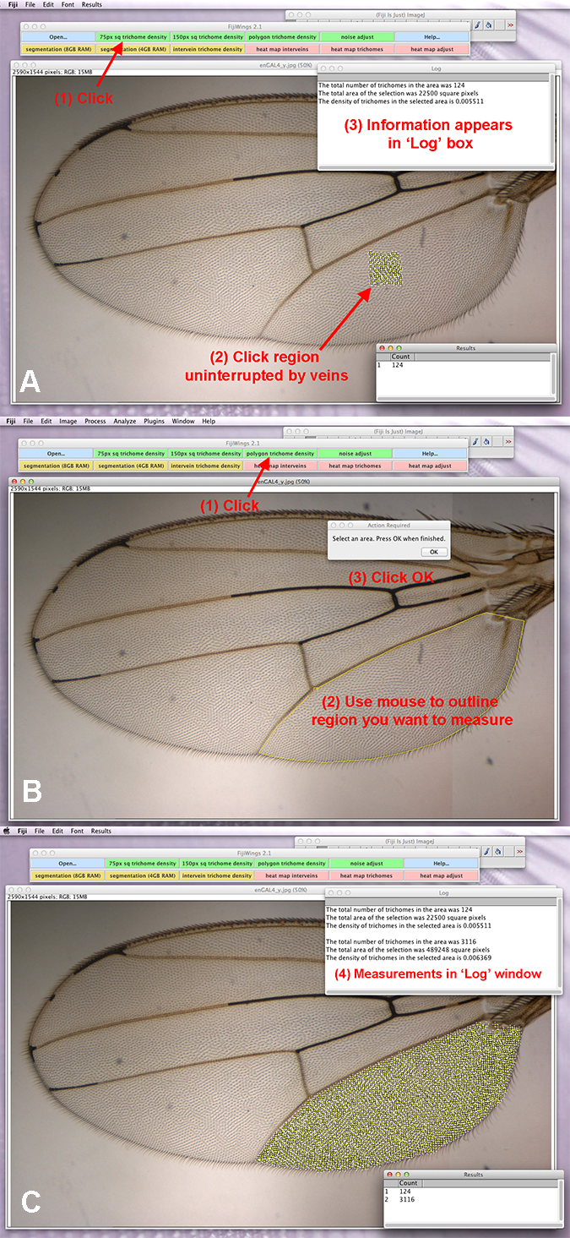
a. Open wing from “Open file…” button, then click the “75px sq trichome density” button. Click on a region of the wing that is uninterrupted by veins to select a 75px region. The total trichome number, area of selection and trichome density will be displayed in the “Log” window.
b. Click “polygon trichome density” button, then use the cursor to draw a polygon around the edge of a wing compartment. Click “Ok” on the popup.
c. The “Log” window containing trichome number, area and density will appear.
  - segmentation
If running Fijiwings on a computer with 8GB RAM, click on ‘segmentation (8GB RAM)’ (Fig. 2a) and give the program 20 seconds to run through a series of macros that automatically identify and outline veins and wing edges in any micrograph and perform particle analysis of the output to outline each intervein region (and generate a region of interest table). If running on a computer with 4GB RAM, click on ‘segmentation (4GB RAM)’ to bring up a new toolbar. Click on STEP 1-4 of the toolbar, giving the program 30 seconds to complete each step. Specifically these macros automatically (a) re-size the image to 512x380, (b) perform Weka segmentation analysis to identify intervein regions on this reduced-size image and then (c) resize the resulting outline, placing it next to the original micrograph. This final output allows the user to proceed to use the “intervein trichome density” or “heatmap” functions, described below. Weka segmentation is RAM intensive and functions best on Macs with 4-8GB of RAM.
The segmentation function places the original micrograph alongside the outlined image, built by a function that identifies the vein and intervein features of the wing. Once this is complete, clicking on intervein trichome density button brings forth a prompt to select an intervein region manually (Fig. 2b). Doing this by clicking on an intervein region outlines it in yellow, and when “OK” is clicked in the prompt dialog box, the macro uses information from the ROI log to calculate (1) area in pixels, (2) trichome count and (3) trichome density (per pixel, Fig. 2c).

Troubleshooting. Fijiwings has some bugs that students will become used to as they use its features. While the trichome density features run without problems, Weka segmentation runs reliably on Macs and Windows7 machines with 8GB of RAM. Error messages we get for Weka on slower machines are due to macros that are launched before the previous task is complete (e.g. “no classified image found” error). We suggest you simply retry with Weka window already open by clicking the ‘STEP 2: WEKA Segmentation’ button again (if attempting segmentation with only 4GB RAM) or close and reopen the image and click ‘segmentation (8GB RAM)’ (if running with 8GB RAM). We also suggest quitting all other open applications/programs to free up available RAM and retry.

intervein trichome density

Fig. 2. Segmentation analysis
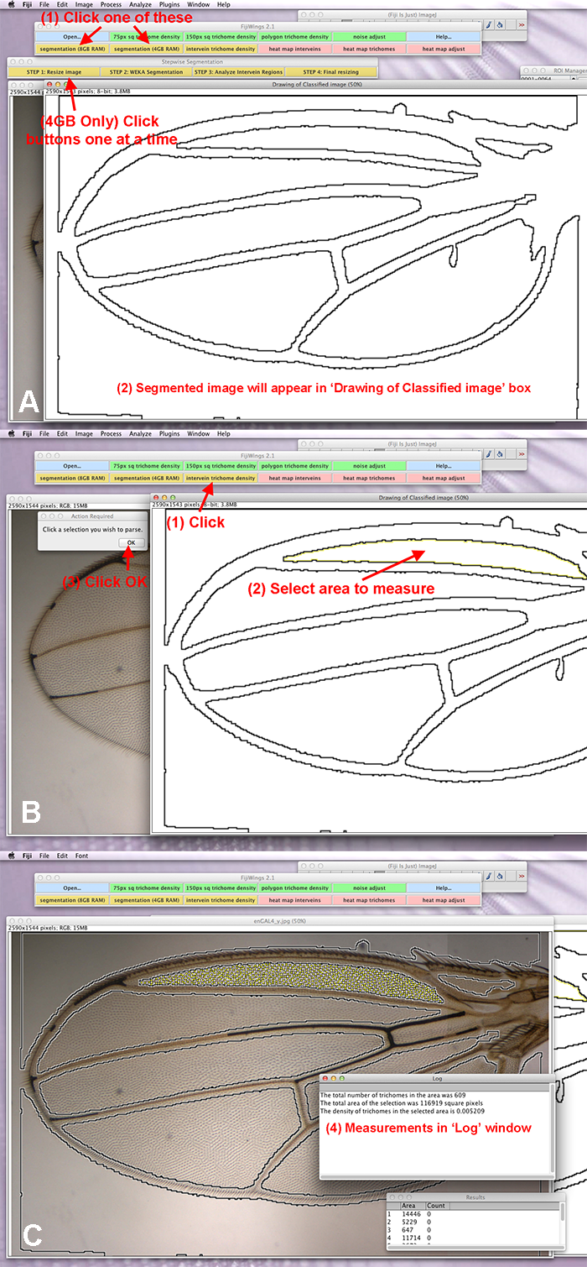
a. Click on either the “segmentation (8GB RAM)” or “segmentation (4GB RAM) button. For the 8GB RAM option, wait for 20 seconds. For the 4GB option, click the STEP 1-4 buttons in order, giving each step 30 seconds to complete. Once segmentation analysis is complete, there should be a window open with an outline of the wing, and a window with the original wing image.
b. After segmentation is complete, click “intervein trichome density” Select a compartment on the drawing on the wing and click “OK” in the popup box.
c. Trichomes are counted on the original image, and the trichome number, area and trichome density will be displayed in the “Log” window.

Fig. 3. Heat maps of tissue and cell size
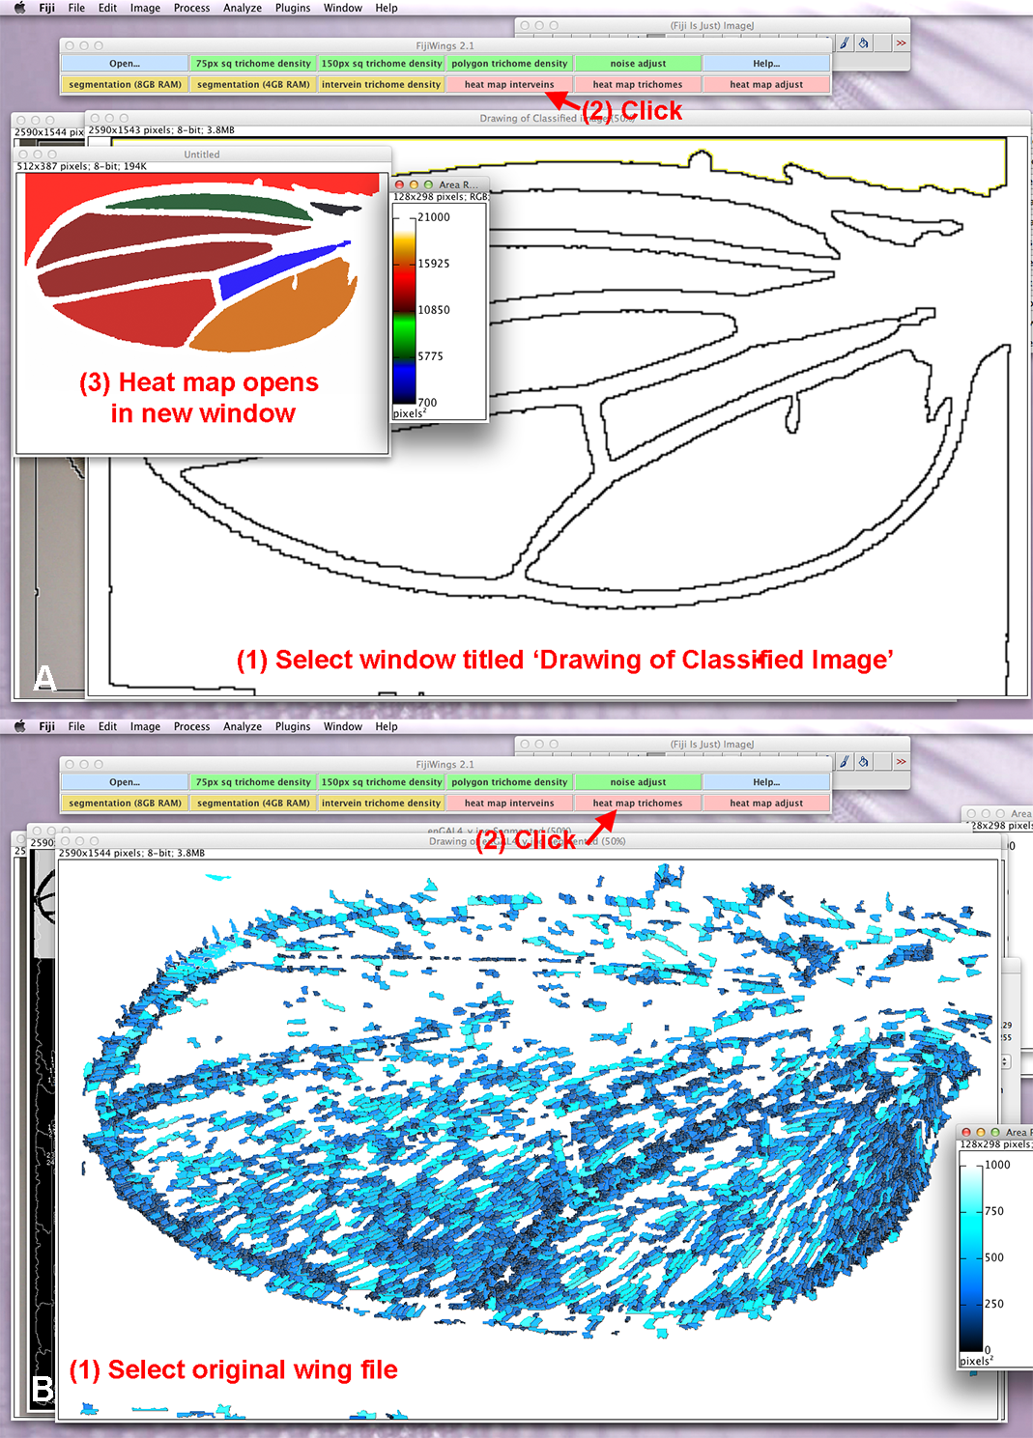
a. To generate a heat map of the wing, select the window containing the “Drawing of Classified Image” and click the “heat map interveins” button. The final heat map image will appear in a small window.
b. To generate a trichome heat map, select the original wing image, and click the “heat map trichomes” button. After 30 seconds, the final image will appear.

  - heat map: intervein regions
This button relies on the ROI (Region of Interest) color coder plug-in (imagejdocu.tudor.lu/doku.php?id=macro:roi_color_coder) to assign heat map colors based on intervein region size determined by segmentation analysis (Fig. 3a).
  - heat map: trichome density
This button relies on the ROI color coder plug-in to assign heat map colors based on trichome density determined by Find Maxima▷Segmented Particles, which finds each trichome, and draw lines between adjacent trichomes and then segments the image by a watershed algorithm; based on the selected small area, a heat map color is assigned (Fig. 3b).
- Examining the effect of insulin signaling on wing cell and tissue size. After becoming expert in evaluating a wild type wing in step #2 (above), download two mutant wing micrograph files available at SourceForge (https://sourceforge.net/projects/fijiwings/): a wing expressing high levels of the gene Tribbles in the posterior wing compartment, which reduces insulin signaling in these wing cells, and a wing expressing an RNAi to the phosphatase Pten in the posterior compartment, effectively increasing insulin signaling. Measure these wings just as you did in step #2 (above) and compare the tissue size/cell size to the anterior compartment and to the posterior compartment of the fly wing. Compare and contrast tissue and cell size for three wings: (1) engrailedGAL4>UAS-Trbl (enGAL4_Trbl.jpg), (2) engrailedGAL4>UAS-PtenRNAi (enGAL4_PtenRNAi.jpg), and (3) engrailedGAL4>UAS-Y (enGAL4_y.jpg):
  - Measure the trichome density of these wings, taking measurements of the marginal cell and third posterior cell (Fig. 4). Cut and paste these measurements from the Log window into a spreadsheet and save the data for transfer into your lab notebook. Your spreadsheet should include separate columns for area, trichome count and trichome density for the marginal cell and third posterior cell from each wing.
  - Measure the area of these wings using the polygon feature and cut and paste these measurements into a spreadsheet and save the data for transfer into your lab notebook.

Fig. 4. Intervein regions in wing misexpressing Trbl
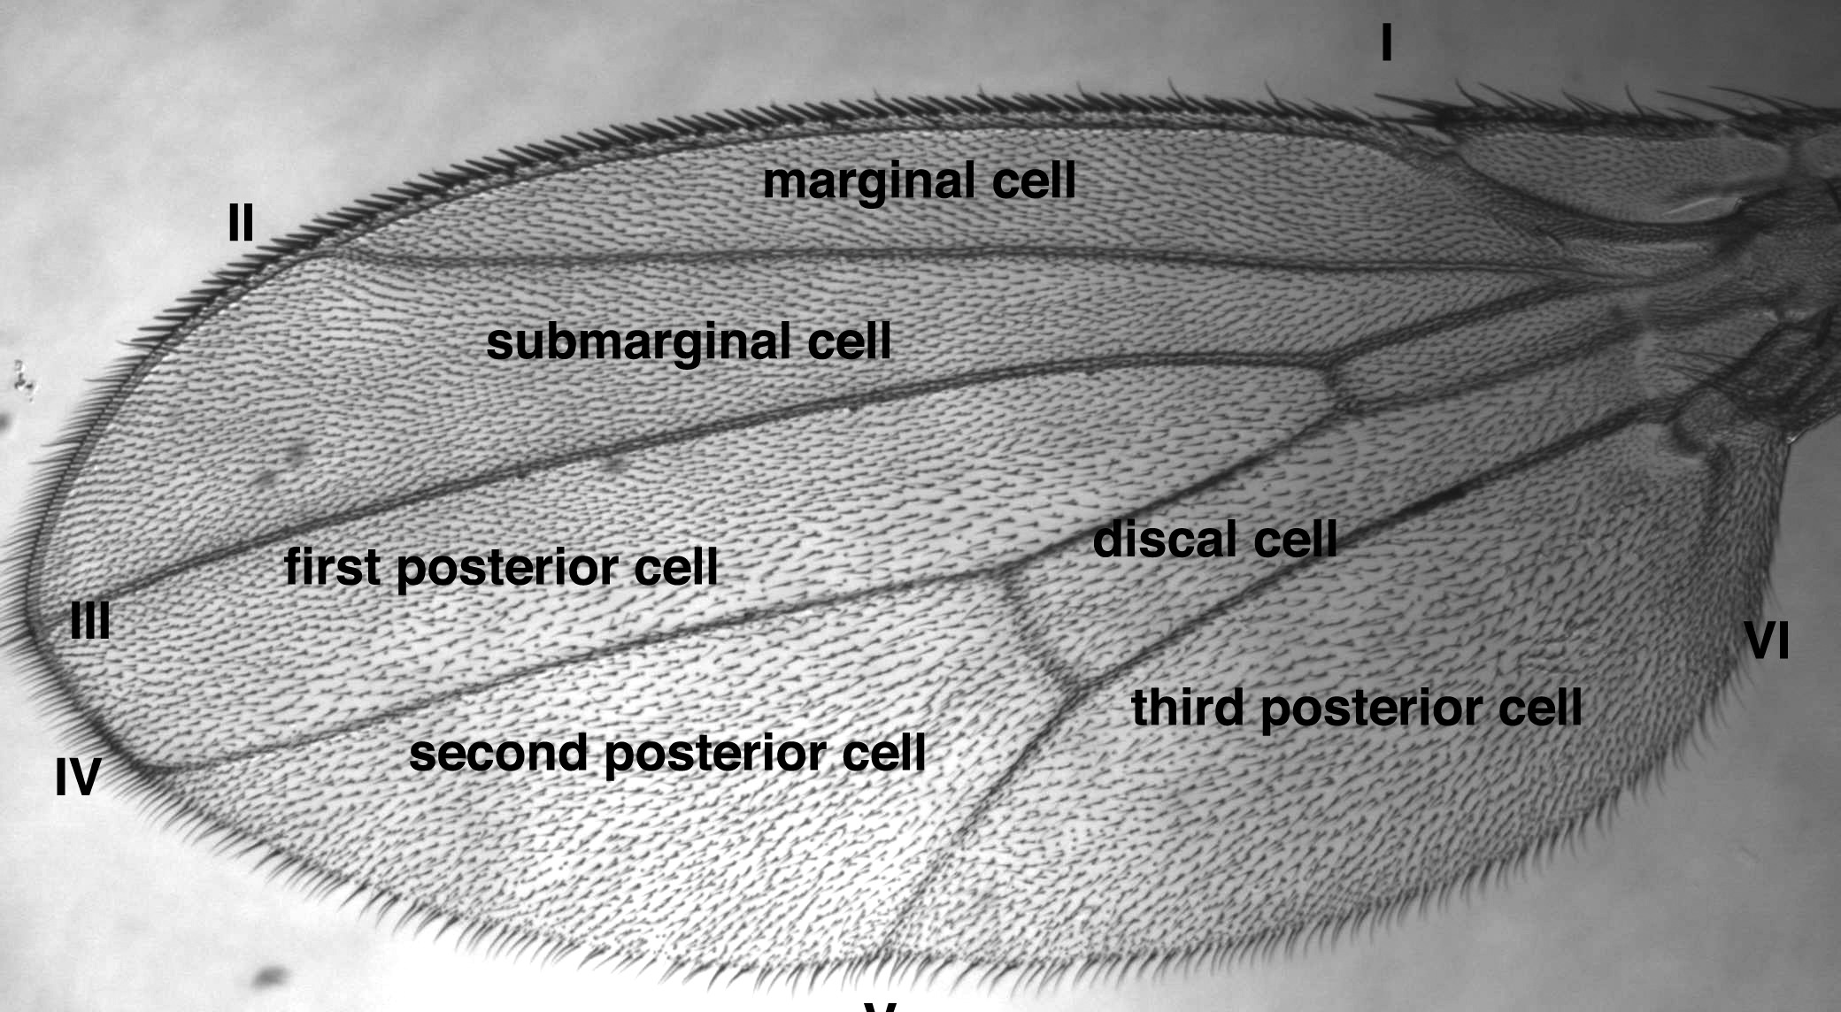
Classic names for intervein regions are shown. Note the reduced density of trichomes in the posterior compartment in this wing misexpressing Trbl
  - Generate a heat map of the intervein region for each wing. Capture the images of these heat maps using the Fiji tool. Plugins▷Utilities▷Capture image (Fig. 5). To save these images, go to File▷Save As… and save as a jpg.
  - Generate heat maps for the trichome density of each wing.

- Analysis of trichome density and area measurements

Fig. 5. Steps to save image data using “Capture Image”
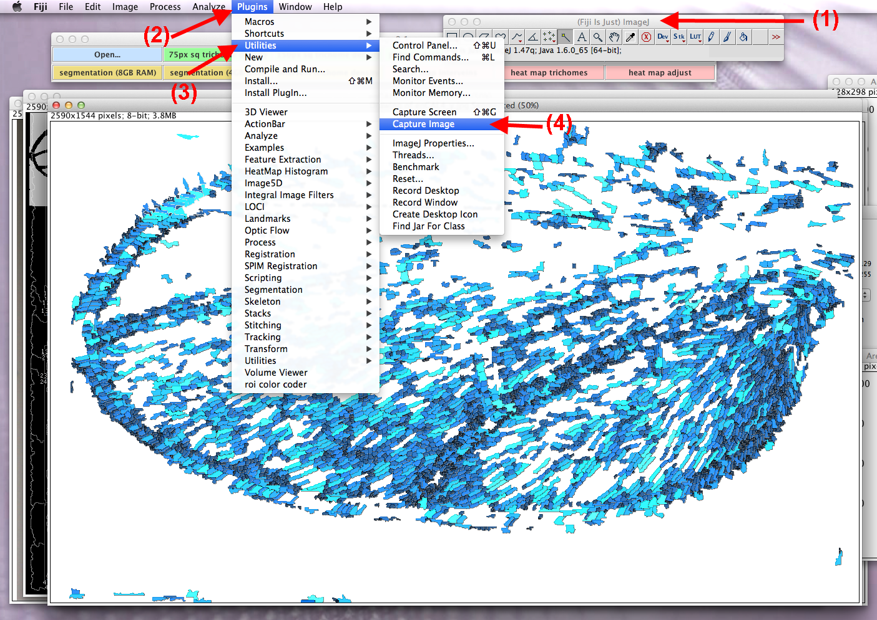
To save the image of the wing heat map or trichome heat map, click on the “(Fiji is Just) ImageJ” toolbar, and then go to the Plugins menu. Select Utilities and go to Capture Image. A new window with the heat map will appear, and this can be saved by going to “File” and selecting “Save As...”

  - Using Excel, generate a graph to compare measurements of the 3rd posterior cell area from each wing. Make sure your graphs are properly labeled and given a title. Create a separate graph to compare the areas of the marginal cells from each wing. What do these graphs tell you about how Trbl and Pten RNAi change the appearance of the wing?
  - Generate a graph to compare the trichome density measurements of the 3rd posterior compartment and the marginal cell from the three wings. Which cell has a greater trichome density in each of the wings tested? Compare your results to the trichome heat map generated in 3d.
  - Using the class data, calculate the mean and standard deviation for the areas and trichome densities of each wing type.

- Critical Thinking Questions
  - Knowing the effect Pten RNAi will have on the wing, what do you predict a wing overexpressing Pten would look like?
  - Look up the insulin signaling pathway in fruit flies. Predict another gene that might cause the wing area to change when expressed or knocked down in the wing. Explain your reasoning.

Module 2: Fijiwings JavaScript macros

Objective: to understand the JavaScript macros running Fijiwings

Introduction
A macro is a simple program that automates a series of commands, and in the case of Fijiwings, each macro directs plug-ins that are part of Fiji/ImageJ (Schindelin et al., 2012). Fijiwings collects a set of macros that run the features of Fiji/ImageJ under the “Action Bar” for easy access. Here we present two approaches to understand macros that are used in Fijiwings.

Step-by-step
To get started, open the file “enGAL4_y.jpg” depicting a wild type wing. Note that when Fijiwings is opened, an “Action Bar” is active and behind this is the Fiji/ImageJ tool bar
Record and run a macro. The easiest way to create a macro is to record a sequence of commands using the “macro recorder” (available by switching to the Fiji tool bar and choosing from the Macro Recorder from the menu drop-down list: Plugins▷Macros▷Record (Fig. 1). By performing some actions on an image opened in Fiji, these actions will be recorded in the recorder window, and you can hit the Create button to open the recorded instructions in an editor. This example will shed light on how the macros running Fijiwings were written and adjusted to work in the context of the program:
- Open a wing image file and from the menu and choose Process▷Find Maxima (Fig. 2). Click ‘OK’ in the popup, and the Recorder will record:
run("Find Maxima...", "noise=10 output=(Point Selection)");

At the same time, local maxima will appear on the trichomes on the micrograph. Click “Create” and an “Editor” window will appear.

- Manually change “noise=10” to “noise=50”. Predict how this will change the number of trichomes detected.

- Click “Run.” Compare the number of trichomes now selected to the original number of selected trichomes.
- Change “noise=50” to “noise=2”. Predict how this will change the number of trichomes detected. (Fig. 3). Click “Run”.

Fig. 3. The effect of manually changing noise
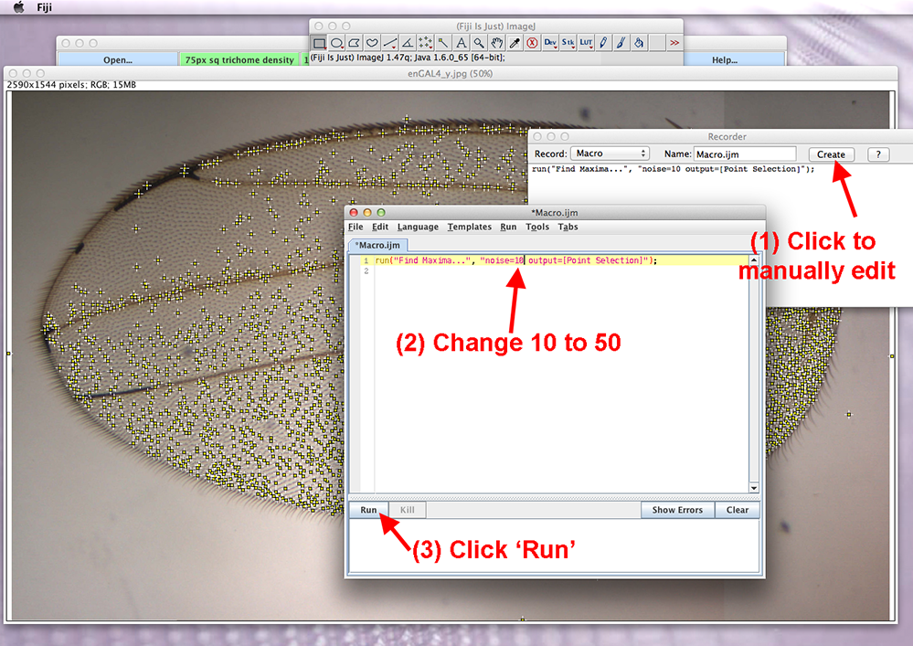
To manually change the noise, click the Create button in the Recorder window. In the macro editor, type a new number to change the noise. To execute the updated macro, click Run.

Fig. 2. Recording “Find Maxima”
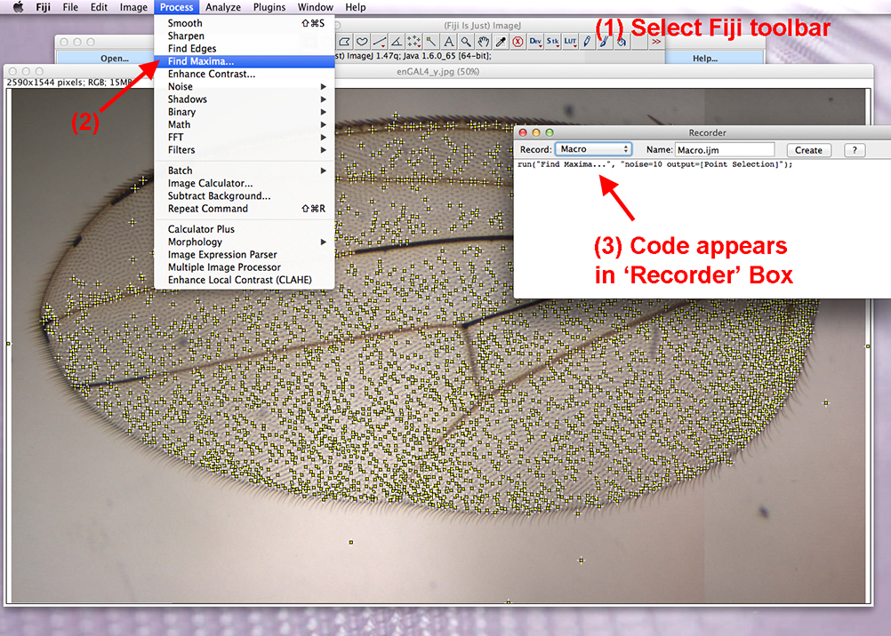
Select the “(Fiji is Just) ImageJ” toolbar and go to Find Maxima under the Process menu. Click “OK” on the popup. Maxima on the wing will be selected, and the action will be recorded in the Recorder box.

Fig. 1. Opening “Macro Recorder”
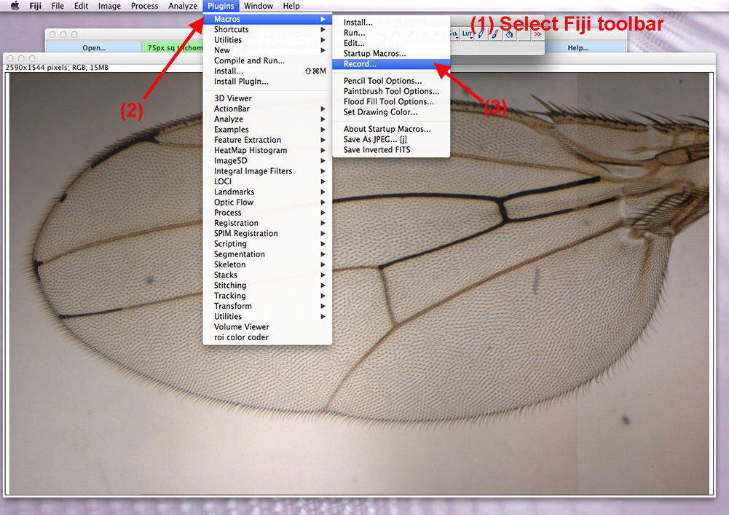
To record a macro, select the “(Fiji is Just) ImageJ” toolbar. Under Plugins, select the Macros menu and hit Record. A textbox labeled “Recorder” will pop up and record subsequent actions.

Manipulate the macros in Fijiwings
Direct access to the macros running Fijiwings can be obtained in the file “Fijiwings_2.1.txt”. On a Mac, this file is located in the folder Application▷Fiji (Right Click-Show Package Contents)▷Plugins▷ActionBar. On a Windows, this file is located in C:/Program Files/Fiji.app/plugins/ActionBar. Opening this file in a dedicated text reader (do not use Microsoft Word) will allow students to look ‘under the hood,’ as it were, and make changes in the underlying Fijiwings macros. This example will shed light on how this set of macros is assembled:

- Search the “Fijiwings_2.1.txt” file (open in Text Edit) using the Command-F function for the phrase “lut=[Cyan Hot]” and replacing it with “lut=[Red Hot]” and then saving the Fijiwings_2.1.txt” file.
- Re-open Fijiwings, open enGAL_y.jpg, and run segmentation. Run “trichome Heat Map” to redraw the map with a different color pallet. Other colors are available at the Fiji menu selection “Image▷Lookup Tables.”

Module 3 (optional): Using Fijiwings to explore the effect of gene activity on cell/tissue size

Objective: to understand how genes regulate tissue and cell size

Introduction

Over the past 15 years, researchers have used the fruit fly Drosophila melanogaster to understand how tissue size is achieved. An excellent model tissue is the fly wing, which forms during the larval stages from an epithelial sheet that proliferates exponentially, roughly doubling in mass over a 10–12 hr. The wing disk epithelium everts at metamorphosis to form the wing blade, which is marked by longitudinal and cross veins that provide structural strength and dotted with actin-rich trichome structures thought to confer aerodynamic properties. From wing to wing, both the shapes and positions of veins and the number and detailed orientation of trichomes are precisely patterned. Extensive work has identified many signaling pathways that pattern wing cell growth and proliferation and key among these are growth factor signals that regulate cell number to pattern the density of trichomes, and insulin signaling, which scales wing growth to the overall body size (Oldham et al., 2000).

The wing offers genetic tools, such as clonal analysis and region specific GAL4 drivers, to perform screens for genes that control cell growth, cell cycle progression, apoptosis, and terminal differentiation. The gene E2F (dE2F in drosophila) controls cell size without affecting tissue size: mutants have reduced numbers of larger cells while increasing dE2F levels results in increased cell numbers but smaller cells (Neufeld et al., 1998). These data suggest that while cell growth and proliferation are linked, it is growth that typically drives wing cells through the cell cycle and not vice versa, just as in yeast (Conlon and Raff, 1999).

This lab makes use of an Engrailed-GAL4 (EnGAL4) driver, which drives expression of a UAS-regulated transgene in the posterior compartment of the wing (Brand and Perrimon, 1993). If the transgenes affects cell proliferation or tissue size, wing or cell size will be changed in a manner that can be measured by Fijiwings.

Step-by-step
Cross. The Engrailed-GAL4 (EnGAL4) driver stock is crossed to a stock bearing a transgene expressing a transgene or an RNAi for a key component of the insulin signaling pathway. A list of these stocks is available at (http://flystocks.bio.indiana.edu/Browse/HD/Metab.php). As a control, EnGAL4 is crossed to UAS-lacZ (http://flybase.org/reports/FBst0003955.html), which does not affect cell growth or proliferation.

To set up crosses, anesthetize flies using ether or CO2; dump flies onto pad, separate males and females. Females are larger than males and have striped abdomens. Males have solid abdomens and sex combs, which are the only reliable way to distinguish the sexes. Dump excess flies into fly morgue (water with a bit of soap).

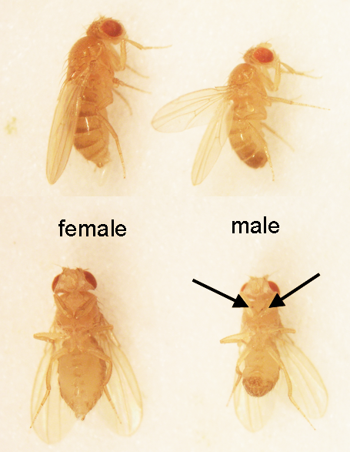

You can reliably expect that females are not susceptible to mating for 8 hours after emerging at 25ºC and for 16 hours at 18ºC. The application of those temperature sensitivities means the following protocol for collecting virgins: empty your vial in the morning, incubate the vial at 25ºC for 8 hours, before you leave at night all the females who have emerged are virgin. Collect these virgin females in an empty vial. Move both vials to 18ºC and in the morning, transfer all females to the fresh vial. Repeat until you have collected enough virgin females for the cross (below).
Cross: For most crosses, 5 virgins and 2 to 5 males per vial will give you a reasonable number of progeny. At least 20 virgins and 5 to 15 males are needed to populate a bottle. Carefully check whether the unconscious flies stick to the food (especially when the food is still wet). Laying the vials on the side until the flies have recovered helps to avoid early losses.
As soon as a culture is set up, the vial must be labeled. Use a waterproof marker to write date and the genotypes of the females and males directly onto the vial.

Wing preps. Proper wing preparation and photography is critical for success in wing morphometry.
- Remove wings from 3-8 day old adult flies (examine females only – remember that males and females are different sizes and thus their wings cannot be compared) using forceps (Dumont #5 Forceps, Fine Science Tools, www.finescience.com) and transferr 5-6 wings to a drop of Euparal mounting medium (Bioquip.com) on a clean cover slip (Fisherbrand Superslip Cover Slips, Fisher Scientific).
- Overlay the coverslip with a clean microscope slide (Fisherbrand Superfrost Plus, Fisher Scientific), allowing the Euparal to spread, then flip the sandwich right side up and use pressure from a probe to spread and separate the wings, remove large bubbles as detected under the dissecting microscope. Smaller bubbles disappear after baking for 24H at 65ºC to slightly harden the Euparal. To aid wing flattening, after 24 hours add weights (cored plug, red brass, 3⁄4-in; Grainger.com) carefully on the cover slip and further bake for another 24H. (optional – with the proper amount of Euparal wings flatten without added weights).
Analysis. To visualize wing preparations, use a Nikon TE-2000 with attached Colorview camera and Analysis image acquisition software microscope at either 200x or 40x with the condenser diaphragm fully closed to maximize contrast. After careful adjustment to focus on trichomes, photomicrographs (resolution 2080x1544) can be collected.
As in module 1, Fijiwings is used to measure tissue and cell size in the wing. To accomplish this, open Fijiwings and click a button directing segmentation analysis to detect veins and interveins in the micrograph; then select manually the posterior intervein region and click “OK”, whereupon Fijiwings detects trichomes and calculates tissue size in pixels and cell size in trichomes per pixels. Data can be collected in the lab notebook and analyzed using statistical techniques used in module 1. Heat maps of wings should also be generated to graphically represent data.

Critical Thinking Questions
- Why are virgin female flies required to make a cross?
- Predict how expressing your transgene in the wing will change tissue and cell size.
- Does your data support your hypothesis? Explain why or why not.

For further reading

Padmanabha, D. and K.D. Baker. 2014. Drosophila gains traction as a repurposed tool to investigate metabolism. Trends Endocrinol Metab 25: 518-527. 10.1016/j.tem.2014.03.011

Dobens, A.C. and L.L. Dobens. 2013. FijiWings: An Open Source Toolkit for Semiautomated Morphometric Analysis of Insect Wings. G3 (Bethesda) 3: 1443-1449. 10.1534/g3.113.006676

Mirth, C.K. and A.W. Shingleton. 2012. Integrating body and organ size in Drosophila: recent advances and outstanding problems. Front Endocrinol (Lausanne) 3: 49. 10.3389/fendo.2012.00049

Chapter 13, Principles of Development, 4th ed. Wolpert, L. and Tickle, C Oxford Press, 2011.

References

Bohni, R., J. Riesgo-Escovar, S. Oldham, W. Brogiolo, H. Stocker, B.F. Andruss, K. Beckingham and E. Hafen. 1999. Autonomous control of cell and organ size by CHICO, a Drosophila homolog of vertebrate IRS1-4. Cell 97: 865-875.

Brand, A.H. and N. Perrimon. 1993. Targeted gene expression as a means of altering cell fates and generating dominant phenotypes. Development 118: 401-415.

Caldwell, P.E., M. Walkiewicz and M. Stern. 2005. Ras activity in the Drosophila prothoracic gland regulates body size and developmental rate via ecdysone release. Curr Biol 15: 1785-1795. 10.1016/j.cub.2005.09.011

Colombani, J., L. Bianchini, S. Layalle, E. Pondeville, C. Dauphin-Villemant, C. Antoniewski, C. Carre, S. Noselli and P. Leopold. 2005. Antagonistic actions of ecdysone and insulins determine final size in Drosophila. Science 310: 667-670. 10.1126/science.1119432

Conlon, I. and M. Raff. 1999. Size control in animal development. Cell 96: 235-244.
Crozatier, M., B. Glise and A. Vincent. 2004. Patterns in evolution: veins of the Drosophila wing. Trends Genet 20: 498-505. 10.1016/j.tig.2004.07.013

De Celis, J.F. 2003. Pattern formation in the Drosophila wing: The development of the veins. Bioessays 25: 443-451. 10.1002/bies.10258
Dobens, A.C. and L.L. Dobens. 2013. FijiWings: An Open Source Toolkit for Semiautomated Morphometric Analysis of Insect Wings. G3 (Bethesda) 3: 1443-1449. 10.1534/g3.113.006676

Edgar, B.A. 2006. How flies get their size: genetics meets physiology. Nat Rev Genet 7: 907-916. 10.1038/nrg1989

Garcia-Bellido, A., F. Cortes and M. Milan. 1994. Cell interactions in the control of size in Drosophila wings. Proc Natl Acad Sci U S A 91: 10222-10226.

Held, L. 2002. Imaginal Discs: The Genetic and Cellular Logic of Pattern Formation (Developmental and Cell Biology Series). 476.

Mata, J., S. Curado, A. Ephrussi and P. Rorth. 2000. Tribbles coordinates mitosis and morphogenesis in Drosophila by regulating string/CDC25 proteolysis. Cell 101: 511-522.

Mirth, C., J.W. Truman and L.M. Riddiford. 2005. The role of the prothoracic gland in determining critical weight for metamorphosis in Drosophila melanogaster. Curr Biol 15: 1796-1807. 10.1016/j.cub.2005.09.017

Mirth, C.K. and L.M. Riddiford. 2007. Size assessment and growth control: how adult size is determined in insects. Bioessays 29: 344-355. 10.1002/bies.20552

Neufeld, T.P., A.F. de la Cruz, L.A. Johnston and B.A. Edgar. 1998. Coordination of growth and cell division in the Drosophila wing. Cell 93: 1183-1193.

Oldham, S., R. Bohni, H. Stocker, W. Brogiolo and E. Hafen. 2000. Genetic control of size in Drosophila. Philos Trans R Soc Lond B Biol Sci 355: 945-952. 10.1098/rstb.2000.0630

Parker, J. 2011. Morphogens, nutrients, and the basis of organ scaling. Evol Dev 13: 304-314. 10.1111/j.1525-142X.2011.00481.x

Schindelin, J., I. Arganda-Carreras, E. Frise, V. Kaynig, M. Longair, T. Pietzsch, S. Preibisch, C. Rueden, S. Saalfeld, B. Schmid, J.Y. Tinevez, D.J. White, V. Hartenstein, K. Eliceiri, P. Tomancak and A. Cardona. 2012. Fiji: an open-source platform for biological-image analysis. Nat Methods 9: 676-682. 10.1038/nmeth.2019

Schneider, C.A., W.S. Rasband and K.W. Eliceiri. 2012. NIH Image to ImageJ: 25 years of image analysis. Nat Methods 9: 671-675.

Shingleton, A.W. 2005. Body-size regulation: combining genetics and physiology. Curr Biol 15: R825-7. 10.1016/j.cub.2005.10.006

